Lab 1. REVIEW OF LINEAR SYSTEMS AND SIGNAL ANALYSIS
Spring 2019

Objective To review the concepts of linear systems and signal analysis through Fourier transformation and filtering

prelab
- Review the Chapter 1 web-notes that pertain to linear systems theory and Fourier transforms.
- Compose a list of Fourier-transform pairs for the following functions (you can look these up):

a) Sin(x) ↔ ?
b) Cos(x) ↔ ?
c) Rect(x) ↔ ?
d) Gaussian(x) ↔ ?
(4 points)
- An RF spectrum analyzer displays the Fourier transform of a time-domain signal, providing its spectral composition. How is this frequency spectrum related to the phase of the signal (if at all)?
(2 points)
- Using MATLAB:
  - Look up the fft(), fft2(), fftshift(), ifft(), ifft2() and ifftshift() commands in the help documentation
  - Try your hand at taking the Fourier transform of the function Sin(t) over an arbitrary range of time using fft() and fftshift() and plot it. How does this compare with what you looked up in 2 a)?
(4 points)

SECTION A: FOURIER SIGNAL ANALYSIS

The purpose of the first part of this lab will be to use Fourier analysis to extract a signal of interest buried in noise.

PART I THE DATA

A plot of the data we will be working with is shown below:
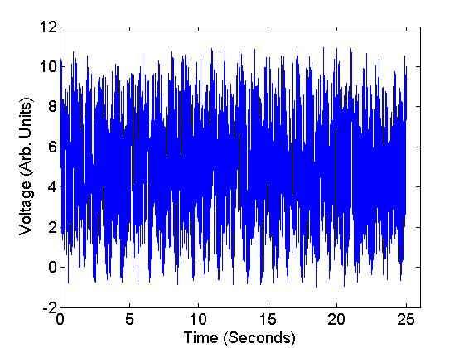

Fig 1. Signal of interest obscured by noise.

Spend some time looking at the data to see if you recognize any patterns. We’ll leave the signal (voltage) units as arbitrary for this exercise.

PART II DATA ANALYSIS

We will be using MATLAB to perform a Fourier transform of the data shown in Fig. 1.

Exercise

1) You will be provided a ‘starter’ excel file that will contain two variables each defined by a set of numbers. These are the Voltage and Time data. Import these data into MATLAB and plot them to verify that the signal has the shape shown in Fig 1.
(2 points)

2) Use the fft() and fftshift() take the Fourier transform of the signal. Obtain a plot of this Fourier transform. From looking at the transform, what can you say about the frequency content of the signal?
(2 points)

PART III DATA FILTERING

In this part, we will be filtering the data to extract the signal of interest from the noise.

Exercise

1) Design a filter function that will allow you to separate the sinusoidal signal from the noise. Plot this filter function.
(2 points)
2) Filter the data by multiplying the filter function with the frequency spectrum (Fourier transform). Plot the filtered spectrum.
(2 points)

3) Inverse-transform the filtered data back to the time domain using ifft() and ifftshift() and plot your result. Compare your result with the plot of the original sinusoidal function used for the simulation (shown in Fig. 2).
(2 points)

It should be interesting to see what you have been able to extract from the mess in Fig. 1. We will use identical methods to perform image filtering and manipulation when we get to Fourier Optics.

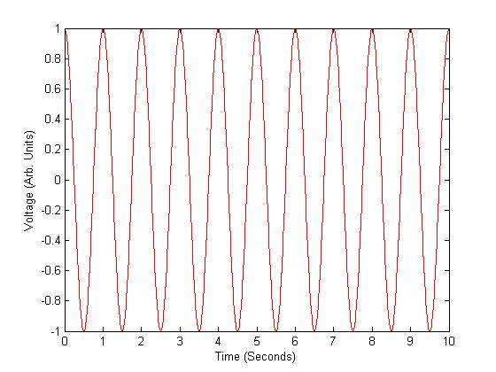

Fig. 2. Sinosoidal function used for data simulation

PART IV DATA FILTERING – CHANGES TO THE BANDWIDTH

Exercise

1) Adjust the filter to make it less optimal, such as by increasing the band pass, or by changing the DC attenuation. Plot the resulting reconstituted sine wave. For example, by broadening the filter bandwidth, you may see something like what is shown in Fig. 3.
(2 points)

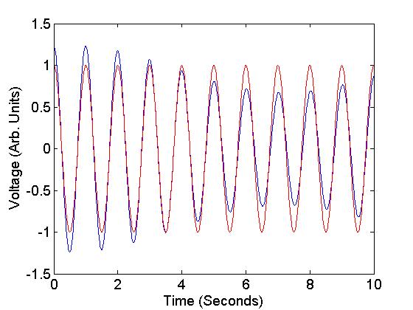
Reconstituted signal
True sinusoidal signal

Fig.3. Reconstituted signal versus true sinusoid used for data simulation

SECTION B: EXPLORING FOURIER TRANSFORM PROPERTIES USING MATLAB

Exercise

- Copy and paste the following code into MATLAB. This code plots an arbitrary signal (represented by variable x) as well as the magnitude, phase and real part of its Fourier transform. It also plots a shifted version of x (represented by variable y).
On running the code you should be able to generate the plots shown below in Fig. 4.

clc; clear all;
t=[0:0.1:(10*pi)];
x=sin(2*t).*gaussmf(t,[5 8]);
shift = ceil(length(t)/3);
y=circshift(x,[0,shift]);
subplot(4,2,1);
plot(t,x);
title('Signal x');
subplot(4,2,2);
plot(t,y);
title('Shifted Signal y');
ax(1)=subplot(4,2,3);
xft=fftshift(fft(x));
plot(t,abs(xft));
title('FT Mag Signal x');
subplot(4,2,5);
plot(t,angle(xft));
title('FT Phase Signal x');
subplot(4,2,7);
plot(t,real(xft));
title('FT Real Signal x');
(1 point)
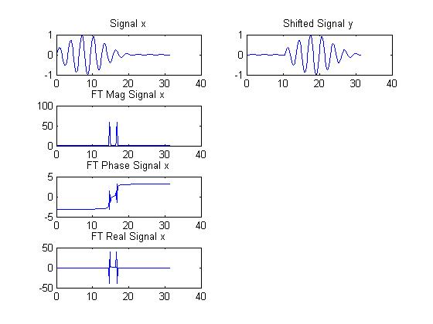
Fig. 4

- Plot the magnitude and phase of the Fourier transform of the shifted signal y. By comparing the phase of y to that of x demonstrate that shifting a signal can be understood as a change in the phase.
(3 points)

SECTION C: FOURIER IMAGE ANALYSIS

In this section of this lab we will be exploring Fourier transformation and analysis for two-dimensional datasets such as images.

PART I 2D FOURIER TRANSFORMS OF COMMON PATTERNS

Exercise

- Copy the following codes into the MATLAB editor to generate the corresponding 2D patterns. Use the imagesc() command to show each of your patterns.:

- Rectangle:
R(1:512,1:512) = 0; R(237:277,237:277)=1;

- Circle:
C(1:512,1:512) = 0;
for row = 1:512
for col = 1:512;
if(((row – 257).^2 + (col – 257).^2)<= 400)
C(row,col) = 1;
end
end
end

- Two dimensional cosine:
for row = 1:512
for col=1:512
CO(row,col) = cos(row)*cos(col);
end
end

- Two dimensional stripes:
x(1:512,1:512)=0;
x(1:10:512,1:512)=1;
x(1:512,1:10:512)=1;
(1 point)
- Use the fft2() and fftshift() functions to generate the 2D Fourier transform of each pattern. Use the imagesc() command to show each Fourier transform.
(4 points)

WRITEUP QUESTIONS

SECTION A

- What was the frequency of the signal of interest buried in the noise?
(2 points)

- How does your reconstructed signal compare with the original data in Fig. 1? If they are different, what might be some of the reasons for the difference?
(2 points)

- Explain how a circuit in a cellular phone receiver might perform Fourier filtering to remove sources of noise to improve the quality of a telephone conversation.
(2 points)

- Suppose the waveform shown in Fig. 1 is generated by a detector in response to a physical event. Now imagine that the same event re-occurs at a later time and is registered on the detector. How would the frequency spectrum of this second occurrence be different from that of the first occurrence? What property of linear systems does this invoke?
(2 points)

- Extra Credit: How much signal power was detected relative to the noise in the system? (Hint: integrate the frequency spectrum over just the filter bandwidth and compare this to the total integrated frequency spectrum.) What can you say about your signal-to-noise ratio?
(1 point)
SECTION B
- Explain why the phase of the Fourier transform of the shifted signal y differs from that of the original signal x.
(1 point)

- Provide a plot of the real part of the Fourier transform of signal y. Why does this plot look different from the corresponding plot for signal x?
(2 points)

SECTION C
- Consider the two dimensional stripes pattern from the exercise in Section C. How would you use Fourier filtering to remove the vertical stripes from the pattern? Sketch what a filter function designed for this purpose would look like.
(2 points)

